Key information – Safer Internet Day 2019
Dear Parents/Carers,
Safer Internet Day 2019
Safer Internet Day 2019 will be celebrated globally today, Tuesday 5th February, with the slogan: ‘Together for a better Internet’.
Coordinated in the UK by the UK Safer Internet Centre the celebration sees hundreds of organisations get involved and join a national conversation about using technology responsibly, respectfully, critically and creatively.
The day offers the opportunity to highlight positive uses of technology and to explore the role we all play in helping to create a better and safer online community. It calls upon young people, parents, carers, teachers, social workers, law enforcement, companies, policymakers, and wider, to join together and help to create a better internet.
The UK Safer Internet Centre invites everyone to join Safer Internet Day supporters across the globe to help create a better internet on Tuesday 5th February 2019, and throughout the whole year!
UK Safer Internet Centre
The UK Safer Internet Centre is a partnership of three leading charities – Childnet International, the Internet Watch Foundation and South West Grid for Learning, (SWGfL) - with a shared mission to make the internet a better place for children and young people.
The partnership was appointed by the European Commission as the Safer Internet Centre for the UK in January 2011 and is one of the 31 Safer Internet Centres of the Insafe network.
The UK Safer Internet Centre delivers a wide range of activities to promote the safe and responsible use of technology by children and young people such as:
- coordinating Safer Internet Day in the UK, reaching millions every year. In 2018 Safer Internet Day reached 45 of young people and 30% of parents in the UK.
- founding and operating an online safety helpline for professionals working with children in the UK, including teachers, police officers, GPs and more
- developing new advice and educational resources for children, parents and carers and teachers to meet emerging trends in the fast-changing online environment
- shaping policy at school, industry and government level, both in the UK and internationally, and facilitates youth panels to give young people a voice on these issues.
Safer Internet Day at St. Joseph’s
At St Joseph’s we are committed to educating our children, of all ages, as to how to conduct themselves safely and appropriately when using online and electronic platforms including websites, search engines, mobile phones and social media. This is a key feature of your child’s learning across the curriculum, including learning in PSHE and Computing, where your child will review online safety on a regular basis.
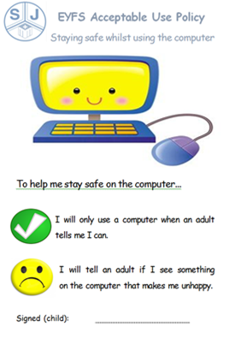
Today your child has been taking part in a series of age appropriate activities to develop their awareness and understanding of online safety. These activities have included whole class and small group activities where children review the following:
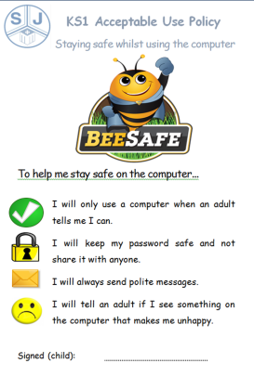
Early Years & KS1
- Describe what the internet is.
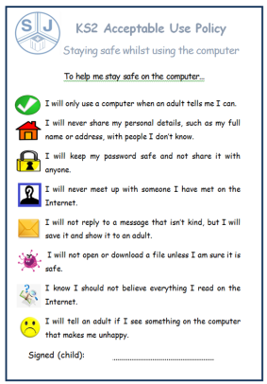
- Name the things they can do online.
- Explain different things they need to ask permission for.
- Recognise how to make good choices online.
- Explore ways to ask others for permission.
Key Stage 2
- Explain what is meant by ‘consent’ and ‘permission’.
- Recognise where they may need to give or receive permission online.
- Understand that choices they make online are important and can have meaning for others too.
As part of their work the children have reviewed (age appropriate) ‘rules’ to stay safe online in our Acceptable Use Policies (copy attached). We would ask all parents and carers to take the time to review this learning and content with your child. Safer Internet Day is a fantastic opportunity to have a conversation with your child about using the internet safely, responsibly and positively. It is a shared responsibility to keep our children safe online and we thank you for your support on the matter. For further information on online safety please refer to our school website http://stjosephsgeorgerow.org/ or speak to a member of the staff team.

St. Joseph’s Staff Team

